TRƯỜNG THCS PHAN CÔNG HỚN
TỔ TIẾNG ANH
TIẾNG ANH 6
TUẦN 30 (TỪ 07/04 ĐẾN 12/04)
WEEK 30
PERIOD 88+89+90: UNIT 9: THE WORLD AROUND US
LESSON 2

Sách giáo khoa trang 73:
New words
- A
- E
- F
- B
- D
- C
Reading - Read & answer the questions
- Yes, he does
- An automatic food machine
- Companies use drones for delivery service.
Sách giáo khoa trang 74:
b. Fill in the blanks
- Might make
- Might live
- Might have
- Might shop
- Might / change
c. Unscramble the sentences
- In the future, we might have robot helpers.
- How might homes change in the future?
- In the future, we might have robot pets
- In the future, doors might have cameras
- In the future, smart doors might not have screens.
SỬA BÀI TẬP TUẦN 29
LESSON 1-1 (New words)

I. Use the following words to write for each picture based on the definition. (Places & Things).
 | smart home | Under the sea | Megacity
 | earthscraper | underground | eco-friendly home
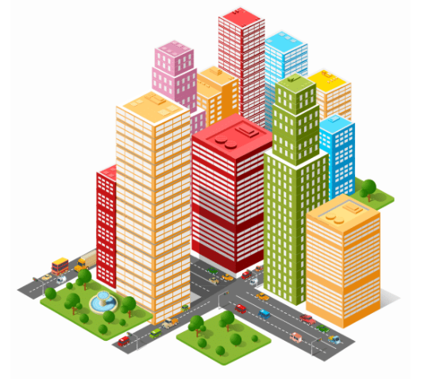 | 
- A very large city; a megalopolis.  Megacity | - A house which is built friendly to natural environment.  eco-friendly home
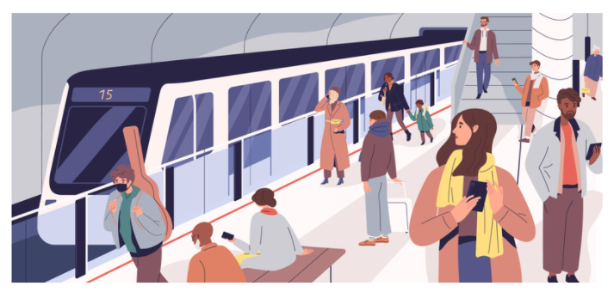 | 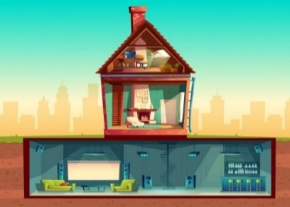
3.Below the ground; below the surface of the Earth or means of transportation.  underground | 4.A building that is built underground.  earthscraper
 | 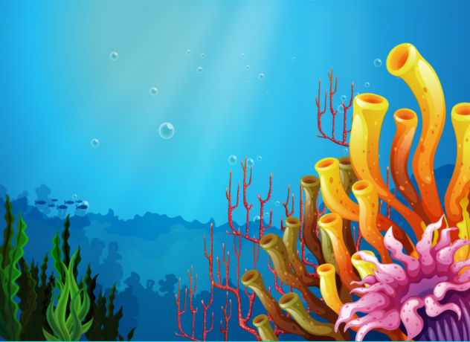
5. A house with a computer to run it.  smart home | 6. Below the surface of the sea  Under the sea

II. Write the correct form of the words in brackets.
1. Life in the city is really different from life in the country. (DIFFER)
2. In the future, many people will live under the sea; so underwater cities will become popular. (WATER)
3. In some countries, people will live underground in earthscrapers. (GROUND)
4. In the next 20 years, many people will live in eco-friendly homes ( FRIEND)
5. In the future, many people will live in megacity – cities with a population of over ten million people. (CITY)

LESSON 1-2 (Grammar)

II. Make future simple questions.
1. Will people live (people/ live) on the Moon someday?
2. What will the cars look (the cars/ look) like in 20 years?
3. Will robots replace (robots/ replace) humans?
4. Where will you be (you/ be) in 2040?
5. When will humans live (humans/ live) on other planets?
6. Will houses be (houses/ be) more environmentally friendly in the future?
7. Will computers take (computers/ take) over the world?

III. Circle the correct answer.
1. There are (a few /a little) tigers at the zoo.
2. Let’s talk to Jane. She has (few/ a few) friends.
3.(A few/ A little) students passed the exam because it was very difficult
4.We saw ( much/ some) beautiful rivers when we went to Vietnam..
5.There are (a little/ some) expensive new flats next to the river.
6.There are a ( few/many) shops near the university.

UNIT 9: HOUSES IN THE FUTURE
Lesson 1-3 (PRONUNCIATION)
I. Find the word whose underlined part differs from the other three in pronunciation.
1. A. flashlights | B. students | C. books | D. schools
2. A. stops | B. showers | C. cleans | D. has
3. A. units | B. topics | C. parks | D. ways
4. A. bins | B. cups | C. trees | D. papers
5. A. machines | B. devices | C. drones | D. companies
6. A. helps B. laughs C. cooks D. finds
7. A. phones B. streets C. books D. makes
8. A. nations B. speakers C. languages D. minds
9. A. works B. shops C. shifts D. plays
10. A. miles B. attends C. drifts D. glows

